Hidden Behind a Screen

Cyber bullying is the most common form of bullying. With over 43% of children, in one class alone, saying that they’ve been hurt online and an astonishing 70% have witnessed bullying on social media sites.

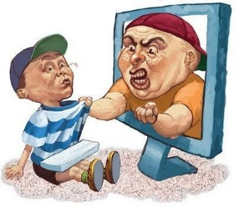In the last 20 years, technology has improved; this means that children have easy access to the internet. Although having access to the internet is good, many people miss-use it and take advantage of the opportunities that it brings.

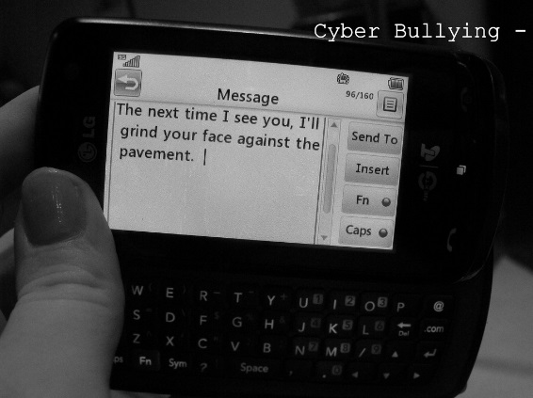Lots of people have admitted to bullying someone online without even realising it. Cyber bullying can be anything from a simple yet nasty text message or setting up a hate campaign against one person. All of these issues are done with the use of a mobile phone and/or the internet.

As over 80% of teens use a mobile phone, it is thought that it’s easier to get away with online bullying, rather than any other form of bullying, i.e. mental and physical.

Per year, an average of 20 children commit suicide, due to the effects of bullying. Hannah Smith’s father knows only too well what it’s like to lose your child…

His daughter “was driven to death by internet trolls”, for using the Latvian based ‘Ask.fm’ website.

David Cameron has been involved with the incident and urges all social network users to “…boycott them, don’t go there, don’t join them.” He described the death as “absolutely tragic”.

The Prime Minister also stated that these “vile websites, that allow bullying to take place…” need to be stopped. The ‘Ask.fm’ website responded to Hannah’s death as a “true tragedy” and they said that they would work with the police to investigate who was responsible for her death.

In recent weeks, several women received rape and death threats on social networking site ‘Twitter’. It seems that the level of cyber trolls has increased, but social networking sites have stayed the same.

Finally cyber-bullying is a huge issue all over the world, and New Zealand is taking dramatic action; they will imprison cyber trolls for up to three years.

Reported by Millie (Year 9)