**Caught in the act**

Bullying is one of the main things that happen in school and out of it.

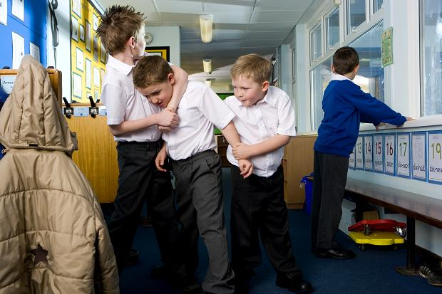The general bullying includes teasing people, talking about them which may hurt their feelings. Spreading rumours about people is one of the many reasons why people are getting bullied, there are many other reasons why people are getting bullied, some of them are; attacking people or yelling at them to make them cry or get upset. Being different such as being a different sex, having a disability, not having any friends, not being able to defend yourself against people. Being religious and being smarter than others is also a cause of bulling.

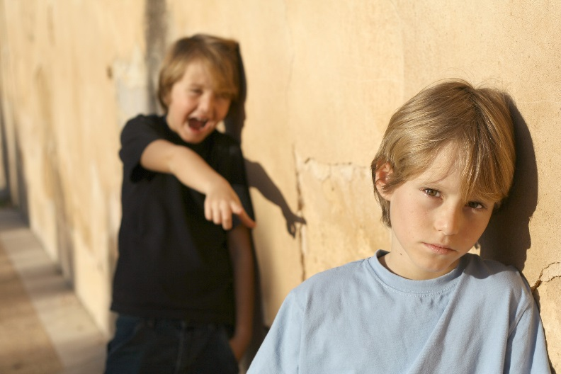Sometimes bulling can make children/people feel sad and lonely, getting sick and feeling sick and having problems at school, sometimes getting bullied makes people want to bully others. A lot of kids bully others because they want to copy their friends and sometimes they just want to do it so they can fit in. the bully sometime does it because he thinks he is better than the victim.

Often people are don’t tell people that they are getting bullied because they are afraid that the bully might find out and hurt them more. A lot of people that are being bullied don’t say NO, they can take it but they don’t give it.

Some schools have anti-bulling guide lines and procedures for dealing with incidents. A lot of schools are trying to encourage anyone who is being bullied, or has witnessed bullying , they are trying to get them to say no. most schools have a bully box, it is where people that are being bullied can tell someone but not face to face. Ideas that some people that have had for bullying are student meetings about what is happening, people generally say if they are getting bullied. Some schools have special teachers that are trained to deal with bulling.

What would you do if you were getting bullied? If you were getting bullied ask someone to help or tell your friends that you were getting picked on. If you are getting surrounded bullies and they are demanding money give them what they want, your life is more important.

What to do if you are getting bullied:

* Try not to show that you are upset or angry
* Try to think up a funny or clever replies in advance
* Keep a diary of what is happening
* Sometimes asking the bully to repeat what they said, it can sometimes put them off. 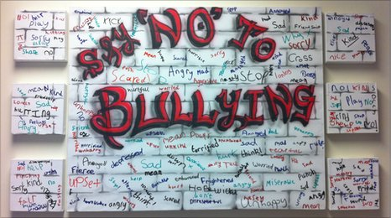

By John, Yana and Clizia