Mata’s Move to Manchester

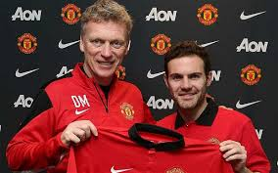Transfers are a huge part of football, most transfers are done pre-season during the summer. But the January window is key. Teams can sign players that will completely altar the rest of a clubs season. In many ways this is a good thing resulting in teams evading Relegation with crucial buys and even clinching promotion. However this can have a resultant effect on other teams. Some people are wanting to stop January transfers. Arsene Wenger has stated he believes the January window is slightly unfair. He said “maybe rules should be adopted for fairness.” Also last year he called for clubs to be limited at signing only 2 new players.

Moving on to the actual transfers now. Arguably the best transfer of the window has just gone through. Juan Mata has moved to Manchester United. Leaving Chelsea for a sum of 37.5 million. Last year he scored 32 goals for the blues in more than 130 appearances. But struggled to find a starting place under Jose Mouriniho. Juan said “the time has come for a new challenge I am excited to have part in the clubs history.” He added “my intentions were to stay during preseason however I started to feel unable to help the team in the way I wanted to, and started to experience difficult situations.” Although I will never forget my affection for Chelsea and the good time I have had.

David Moyes, United’s manager has stated “Juan is one of the finest players in the game today .I’ve been surprised by the excitement he has shown towards joining the club.” He added “the fans have admired Mata for a long time and I know they will be excited to see him in red.” Also Mata’s former boss, Jose Mouriniho said he would’ve liked to play Juan more but he felt better options were available such as Oscar. Also Chelsea fans have said “Mata you deserved better, we loved you.” And “Chelsea have played better without Mata.” Also one experienced old Trafford observer has said “Mata is a panic buy however a very good one.”

It remains to be seen how this move affects the title race but the future will reveal that soon.

By Alex, Jordan and Herbie.