UK give unnecessary money to foreign aid?
Even though the UK’s national debt is increasing by approximately £121 billion per year or around £ 2.3 billion a week Britain keep giving 0.56% of our income to foreign aid and we also plan to give 0.7% in future years. But is this money actually going to the people who really need it and isn’t now the time to rebuild our economy?
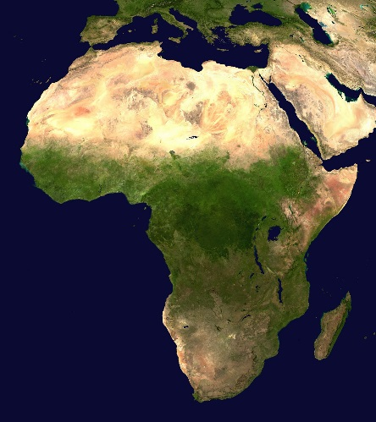
Many people doubt this as many countries and continents especially Africa where most of our money goes to are corrupt and the money just goes to the wealthy who don’t need the money.
At the moment the UK gives the second highest amount of money to foreign aid behind USA – but as a proportion of national income that was just a small 0.19% which is four times less than the Uks.
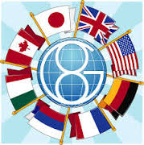
A report revealed that the amount of tax payers cash spent on foreign development has soared 65 per cent over the last decade to a massive £8.3 billion last year. The increase is more than double that of the G8 group of nations made up of the UK, Germany, France, Russia, Japan, Italy, Canada and the USA as a whole.
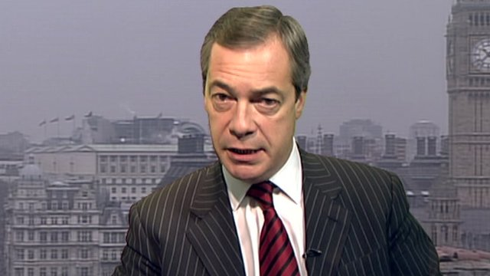
Ukip leader Nigel Farage said “Britain’s foreign aid budget is rising while hospital accident and emergency departments, libraries and other public services are being cut back or closed down.”

Matthew Sinclair, chief executive of the tax payer’s alliance said: “it’s absurd that the UK continues to increase the size of its aid budget far faster than the rest of the G8 despite the huge financial pressures at home.”

So not many people are happy are happy with the amount of money the UK are giving to foreign aid and the money is only going to increase.

By Thomas (Year 9)

