Violence and Video Games: Is There A Link?

On December 14th, 2012, Adam Lanza shot and killed 20 children and 6 others, including his mother, at the Sandy Hook Elementary School. The second most deadly school massacre in U.S. history, it sparked debates both about gun control and the long-standing issue of video game violence.

Adam Lanza, aged only 20, trained for his deadly massacre using the popular first person shooter (FPS) Call of Duty – but he is not the first one. In 1997, a 14-year-old killed multiple people at his high school in Paducah, Ky. In 2011, he was released and went on to murder 77 people at a summer camp in Norway. He was inspired by the sci-fi shooter Doom, and the beat ‘em up Mortal Kombat.


Doom came under direct attack after the Columbine high school massacre. On April 20th 1999, two seniors Eric Harrison and Dylan Klebold walked into their high school and proceeded to shoot and kill 12 students, and their coach. 24 others were also injured as they tried to escape. The boys both had an intense fascination with the virtual massacre games Doom, Quake, and the Nazi centred Wolfenstein 3-D, filled with frequent references to Swastikas and Hitler’s closest party members. Harris and Klebold ran a fan-site devoted to Doom, posting custom maps he’d spent countless hours working on online. The games of the games adorned their journals alongside maps of their school, illustrations of the outfits they would wear for the massacre.
In 2006, an Alabama teen by the name of Devin Moore was arrested on suspicion of car theft, despite having no past criminal record. However, when he was brought to the station, he became hostile. He attacked a police officer, stole his gun, shot him and two other police staff, and then took the keys to a patrol van and drove away. He had supposedly been playing a lot of the free-roaming role playing game Grand Theft Auto.
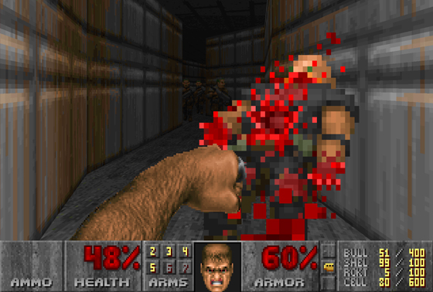
Video game addiction is also an issue in modern society. In 2005, a young man in South Korea died from a cardiac arrest after playing StarCraft for 50 hours in an internet café. He rarely took breaks, except for refreshments. The cause of his heart attack was exhaustion. A few years later, a schoolboy in Beijing led himself to believe he was a Fire Mage from the popular MMORPG World Of Warcraft. He proceeded to set his classmates on fire using a can of gasoline and household matches.

The sheer volume of video-game related murders and mental illnesses would make anyone wonder: is there a link?

No, say researchers. "Our research found that certain patterns of video game play were much more likely to be associated with these types of behavioural problems than with major violent crime such as school shootings,” said one researcher. In 1999, a study sponsored by the U.S. government came to the conclusion that video games did not cause direct violence. Surgeon General David Satcher said that "we clearly associate media violence to aggressive behaviour. But the impact was very small compared to other things. Some may not be happy with that, but that's where the science is.” Following this, a meta-analysis by psychologist Jonathan Freedman was released in 2007, in which he reviewed over 200 studies and also reached the same conclusion, finding that the "vast and overwhelming majority" did not cause a direct and common link. Entertainment media has always been good at laying the blame for negative actions on young people. Since the 1950s, various forms of media have been blamed, including comic books, heavy metal, punk, and rock ‘n’ roll. They have been blamed for inciting acts such as violence, suicide, drug use and other illegal acts. Nonetheless, now, the blame has shifted to video games. It is a continuing cycle, and there are always trends, falling in and out as the media deems fit.

If your children are violent after playing video games, it may be a sign of psychopathic personality disorder. People with some forms of a psychopathic personality disorder see violence as the only way to solve a social issue. Whether they consumed violent media or not, their reaction would be the same. National trends also prove this – when video games with higher ratings begun being published more often, the national crime rate has dropped.

Scientists and Psychologists have been researching video games and their role in the average person’s life for decades. Despite years of research, links between violence and video games are coming up short – at most, researchers found increased hostility and heart rate. It is unlikely that a definite link will be found anytime soon, but with development of immersive virtual reality software such as the Oculus Virtual Reality Headset, new links and theories may soon be found.

Report by Bryony, Archie, and Stanley

